- Governor Andrew Bailey is the Monetary Policy Committee's swing voter and has suggested that progress in upcoming inflation prints and a Budget that tightens fiscal policy would shift his vote to a cut in December. Though this week's inflation data wasn't overwhelmingly dovish, we think it showed enough promise to clear the first hurdle to a December rate cut.
- Meanwhile, the week's activity data offered some additional dovish signals. Retail sales volumes fell sharply across all the major categories in October, after a recent period of outperformance. At the same time, November's S&P Global survey suggested private sector momentum remains modest at best, and we expect this trend to continue over the coming quarters.
The minutes of November's Monetary Policy Committee meeting suggested the next two inflation releases and the upcoming Budget would be crucial to whether the committee's swing voter Governor Andrew Bailey would switch his vote to a cut at the next meeting. The first of those releases was published this week and appeared to keep the MPC on track to cut rates in December.
The Office for National Statistics reported that CPI inflation fell to 3.6% in October from 3.8% in September, in line with the Bank of England's staff forecast. A 0.2ppt drop in the contribution from the energy category fully accounted for October's softer headline reading, as the month's 2% rise in Ofgem's energy price cap was much smaller than the 9.5% increase seen last year.
Movements in the other main inflation categories largely offset one another. Services inflation also fell by 0.2ppts to 4.5% in October. But this was primarily driven by movements in volatile categories, such as air fares and hotel prices, while the MPC's favoured measure of underlying services inflation – which excludes indexed prices and some of the more erratic components – rose slightly in October (Chart 1). The downward pressure from weaker services inflation was mitigated by higher food and fuel prices.
Chart 1: Services inflation cooled in October, but underlying price pressures ticked up
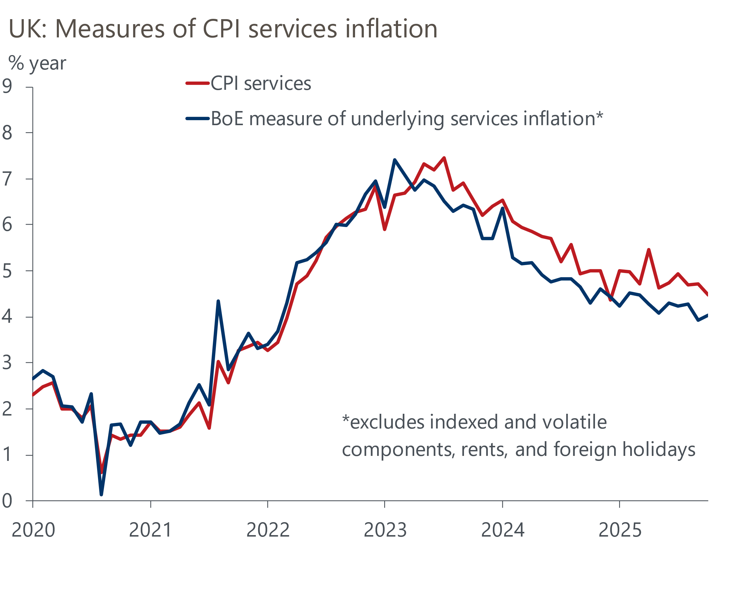
Source: Oxford Economics calculations using data from Haver Analytics

The statements from individual MPC members in November's meeting minutes suggest most of the committee's viewpoints are relatively well entrenched, and we suspect the committee's hawks and doves will have drawn contrasting conclusions from this week's inflation data.
For the MPC's more hawkish members, October's rebound in food prices is likely to have renewed concerns that high inflation in salient categories, such as food, might push up inflation expectations among households and firms, and reinforce inflation persistence. Huw Pill and Catherine Mann both argued in speaking events this week that underlying measures of inflation continue to show upside risks from an accumulation of supply shocks in recent years, which have altered the structure of price- and wage-setting. So these members are likely to have seen further stickiness in measures of underlying services prices as a sign that these dynamics continue to linger.
But ultimately, Bailey is the committee's swing voter, so his views will determine the path of rates in the near-term. His statement in the November minutes intimated that he wanted to see further disinflation progress before the December meeting. Given this relatively low bar, we think this week's data showing that inflation has now passed its peak and is on the path downwards means the first hurdle to a rate cut in December has been cleared.
The second barrier comes next week, when the Chancellor delivers her Budget, which seems almost certain to deliver a large consolidation. Next month's inflation release will be the final obstacle, but inflation should remain below the 3.8% rate seen at the time of the November meeting.
Though Bailey's primary focus appears to be on official inflation releases and the upcoming Budget, he has also suggested that soft demand was a factor behind his view that the balance of risks to the inflation outlook is to the downside. Coming after last week's disappointing labour market and GDP releases, this week's activity data further strengthened his case.
Retail sales volumes sank 1.1% m/m in October after a series of unsustainably strong outturns, with all of the major categories seeing spending fall (Chart 2). The weaker outturn reduces the gap between the retail series and other consumer indicators, which have been much softer in recent months.
Chart 2: After a period of outperformance, October's retail sales saw a broad-based fall
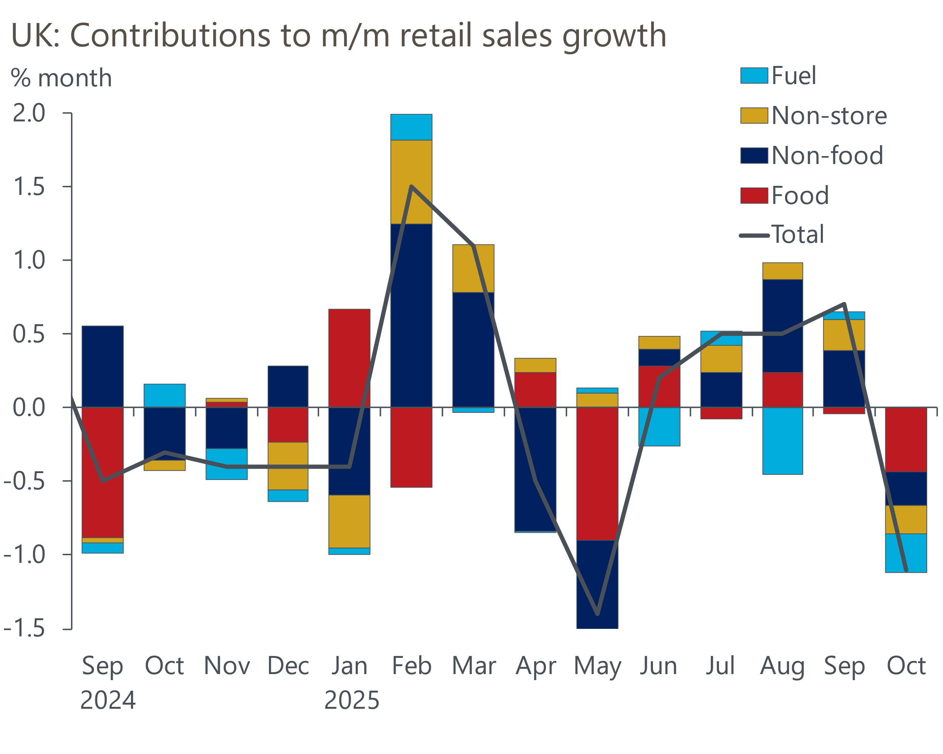
Source: Haver Analytics
November's flash S&P Global survey sent a similar signal. The composite reading of 50.5 was a notable stepdown from October's 52.2. And while some of the month's weakness can be chalked up to pre-Budget jitters, private sector momentum looks modest at best. We expect this pattern to continue over the coming quarters.
These developments lend further weight to Bailey's argument that soft demand is likely to weaken firms' pricing power and limit the impact of elevated household inflation expectations. As a result, we think this week's data keeps the MPC on track to deliver a 25bp rate cut next month.

The week ahead
In what will be a quiet week for economic data releases, all eyes will be on the Budget. We think Chancellor Rachel Reeves will need to tighten policy by £20bn-£25bn to comply with her fiscal rules while maintaining the same slim headroom as the past two fiscal events. This reflects likely downgrades to the Office for Budget Responsibility's very optimistic potential growth forecasts, the cost of recent government U-turns on welfare reforms and winter fuel payments for some pensioners, and higher debt servicing costs. Further tightening will be needed if the Chancellor opts for greater headroom.
With recently announced departmental spending allocations for the period to 2028-2029 unlikely to be revised, the only scope to cut spending appears to be in 2029-2030. Meanwhile, markets would almost certainly punish the government should it water down any of the fiscal rules. Therefore, hefty tax rises are likely to account for most of the consolidation. We think extending the freeze on tax thresholds and allowances beyond 2027-2028 will form a key part of the package. Beyond that, the Chancellor appears likely to tap a wide range of smaller taxes for additional revenue.
Table 1: Week ahead calendar
Date | Events | Period | Measure | Unit | Previous | Forecast
Nov 26 | Budget
Nov 28 | Nationwide house prices | Nov | m/m | % | 0.3 | -0.1
Nov 28 | Nationwide house prices | Nov | y/y | % | 2.5 | 1.4
Source: Oxford Economics

Key forecasts
Table 2: UK forecast overview
(Annual percentage changes unless specified)
 | 2023 | 2024 | 2025 | 2026 | 2027 | 2028
GDP | 0.3 | 1.1 | 1.4 | 0.9 | 1.3 | 1.6
Private consumption | -0.3 | -0.2 | 0.9 | 1.0 | 1.1 | 1.5
Fixed investment | 0.5 | 1.8 | 2.8 | -0.1 | 1.5 | 2.0
Government consumption | 2.1 | 3.4 | 2.0 | 1.6 | 1.6 | 1.7
Exports of goods and services | -2.3 | 0.6 | 2.8 | -0.2 | 1.2 | 1.5
Imports of goods and services | -1.6 | 2.6 | 3.5 | -0.7 | 1.2 | 1.5
Industrial production | -2.6 | -1.6 | -0.5 | -0.1 | 1.1 | 1.3
Consumer prices | 7.3 | 2.5 | 3.4 | 2.8 | 2.5 | 2.2
Unemployment rate (%) | 4.1 | 4.3 | 4.8 | 5.1 | 5.0 | 4.6
Current a/c balance (% of GDP) | -3.6 | -2.2 | -3.0 | -2.6 | -2.4 | -2.3
Government balance (% of GDP) | 5.2 | 5.2 | 4.8 | 3.4 | 3.1 | 2.7
Central bank policy rate (%, EOP) | 5.25 | 4.75 | 3.75 | 3.25 | 3.00 | 2.75
10yr govt. bond yield (%, EOP) | 3.54 | 4.57 | 4.60 | 4.24 | 3.76 | 3.48
Exchange rate (US$ per £, EOP) | 1.27 | 1.25 | 1.29 | 1.29 | 1.29 | 1.29
Exchange rate (euro per £, EOP) | 1.15 | 1.21 | 1.11 | 1.11 | 1.11 | 1.11
Source: Oxford Economics
Table 3: Quarterly forecasts for the UK
 | 2025 |  |  |  | 2026
 | Q1 | Q2 | Q3 | Q4 | Q1 | Q2 | Q3 | Q4
GDP (% year) | 1.8 | 1.4 | 1.3 | 1.2 | 0.8 | 0.8 | 1.0 | 1.0
CPI inflation (% year) | 2.8 | 3.5 | 3.8 | 3.6 | 3.3 | 2.5 | 2.7 | 2.6
Bank Rate (%, EOP) | 4.50 | 4.25 | 4.00 | 3.75 | 3.75 | 3.50 | 3.50 | 3.25
10yr gilt yield (%, EOP) | 4.70 | 4.48 | 4.70 | 4.60 | 4.57 | 4.49 | 4.38 | 4.24
US$ per £ (EOP) | 1.29 | 1.37 | 1.35 | 1.29 | 1.29 | 1.29 | 1.29 | 1.29
Euro per £ (EOP) | 1.20 | 1.17 | 1.15 | 1.11 | 1.11 | 1.11 | 1.11 | 1.11
Source: Oxford Economics

Latest Country Economic Forecast:
November 18, 2025

Recent publications

Data Insights
Pre-Budget concerns weigh on the PMI
October's drop in retail sales shouldn't be a source of concern
Precarious public finances make for a difficult Budget
October's softer inflation print keeps December rate cut on track
GDP fell in September, as industrial production slumped

Research Briefings
Better affordability puts housing market on firmer footing
Dovish hold in November puts a December rate cut in play
MPC preview – softer data unlikely to herald November cut
What should the Chancellor do in the Budget?
What happens if markets lose faith in the fiscal approach?

Contacts

Oxford Economics' UK team
- Andrew Goodwin - Chief UK Economist - agoodwin@oxfordeconomics.com
- Edward Allenby - Senior UK Economist - eallenby@oxfordeconomics.com

